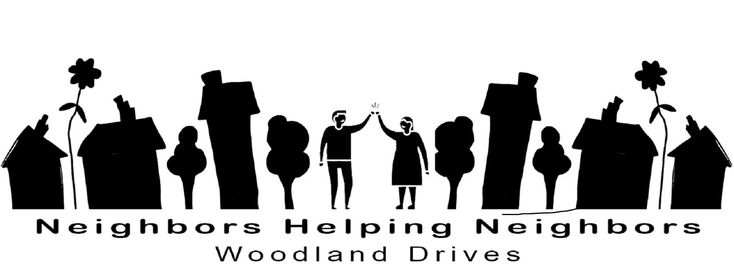
NHN Volunteer Waiver

By signing below, I acknowledge that Neighbors Helping Neighbors/Woodland Drives Neighborhood Association (NHN/WDNA) links residents to volunteers. Requests for service are made by the resident to NHN, and NHN refers the resident to an approved volunteer for the performance of the requested service. Volunteers are strongly encouraged not to provide their personal contact information to residents.
I also understand that NHN does not screen clients, residents, volunteers, or other service providers for any health condition, including any communicable disease, and I waive any claims against NHN related to any illness or health condition that may be transmitted among clients, residents, volunteers, or other service providers.
By signing below, I hereby agree and understand that all information about a customer or resident, including, but not limited to, the health, social, or psychiatric condition of a participant; any contact information such as an e-mail address, phone number, street address, etc.; and marital status is confidential. I agree to not discuss, publish, convey, or otherwise use or disclose such personal information with anyone outside of NHN.
I understand that, as a volunteer for NHN/WDNA, a service recipient may offer a gift or some other form of payment for my volunteer efforts. Since accepting gifts complicates the volunteer-client relationship, I will not accept any form of payment from a client for my volunteer efforts.

By signing below, I also hereby waive any and all claims against NHN/WDNA and any of its agents on behalf of myself for any loss or harm that may arise in any way from a resident that I learn about from NHN/WDNA.

Signed: ___________________________________

Printed Name: ___________________________ Date__________________

